Creating and Editing Shape Files for Use in Gale Analytics

Contents
Part 1. Introduction to File Types and Tools 2
The KML File 2
The Name Tag 2
The Create a Service Area App 2
Lines vs. Polygons 4
Google Earth and Google Maps 4
Part 2. How To Create a Single Shape for a Service Area 4
Geography List 4
Drawing a Shape 5
Part 3. How To Create Multiple Shapes for Branch Service Areas 8
Geography List 8
Drawing Multiple Shapes 8
Part 4. Editing Existing Shape Files 9
Editing the Name Tag 10
Convert Lines to Polygons 10
Editing Name Tags in Multiple-Shape Files 11
Google Earth Steps 11
Google Maps Steps 12
Combining Shape Files in Google Maps 16
Workaround for 10 Layer Limit. 18
Part 5. Including Branch Points 20
Points in the Create a Service Area App 20
Drawing Points 20
Adding to an Existing .KML File 21
Google Earth and Google Maps 22

This document will go through the options and steps of creating and editing shape files, eventually creating .kml files that can be used in Gale Analytics.

Part 1. Introduction to File Types and Tools

The KML File
.KML files are Google shape definition files. The .KML file has the most options for editing in free tools and the most robust support within the Gale Analytics apps, so the .KML file is the preferred shape file format.
In creating a multiple-shape file for branch shapes, a .KML file is the only option that allows for multiple shapes that can be used within Gale Analytics. However, in a single-shape file to define a service area multiple formats are accepted including .SHP (ESRI Shapefile), .TAB and .MIF (MapInfo), .GRC and .GRD (GIS Mapping) and .GEO (SRC Geography) in addition to .KML.
This document will deal mostly with the .KML file.

The Name Tag
Within each shape file, usually not visible unless opened in Google Maps or Google Earth, is the name tags, which contain the name given to the shape itself within the shape file.
Whether using the single shape for a service area or multiple shapes to represent branch areas, the name of the service or branch area that will output in the Tableau report will be based on the values within the name tag.

The Create a Service Area App
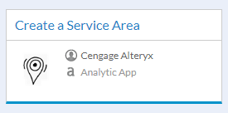
1 - The Create a Service Area app as it appears in Gale Analytics
Create a Service Area is one of the utility apps and is available within the “Home” link on the main page within Gale Analytics. This app will allow users to create both single-shape and multiple-shape files in two ways, by choosing one or more geographic areas from a list:
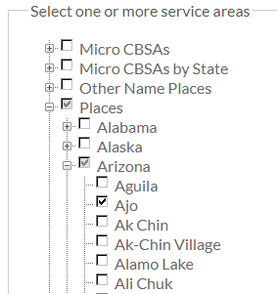
2 - The Geography List in the user interface of Gale Analytics apps
Or by drawing outlines on a map:
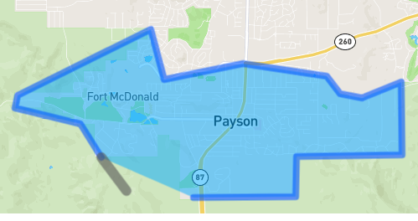
3 - The drawing functionality within Create a Service Area
The app will also allow editing of the names of the shapes, as well as converting a line to a polygon (see below).
More details about the Create a Service Area app will be seen throughout this document.

Lines vs. Polygons
One of the most common errors when creating shape files is creating a line instead of a polygon. Both look identical but the line is not a geographic area, it is just an outline of that area. While the fully functional geographic area is referred to as a polygon and contains a complete definition of that area.
What this means for Gale Analytics is that the apps will not be able to process any geographic information from the line file. The Executive Summaries, Non-Patrons, Market Penetration, or simply whether a patron is within or outside of the service area will not work with a line file.
The good news is that all the Gale Analytics apps that work with shape files will show an error if the imported shape file is not a polygon.
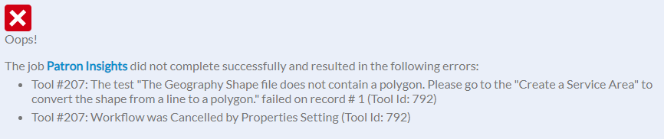
4 - The error message if a shape file contains lines instead of polygons
If this error shows up, the Create a Service Area app can be used to convert the line to a polygon. Simply upload the shape file used and the app will output a polygon. Regardless of the input format, the output will be a .KML file.

Google Earth and Google Maps
Google Earth (https://earth.google.com/) and Google Maps (https://www.google.com/maps/) are free tools that can be used to create .KML file or edit or combine existing .KML files

Part 2. How To Create a Single Shape for a Service Area
Creating a single shape to be used as a service area within Gale Analytics can be created with the Create a Service Area app. As mentioned above, there are two main ways to create a service area: by selecting from a geography list or from drawing the lines on a map.

Geography List
Within the Create a Service Area App, the first option is the type of service area. The options here are either “Single Service Area” or “Multiple Branch Areas.” Select “Single Service Area” and all of the selections will be combined into one service area.
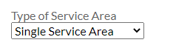
5 - The "Type of Service Area" field within the user interface of Create a Service Area
The default option is “Select Service Area,” which is the option to use the geography list. Simply open up the tree and select one or more geographies to be the service area.
The name of the area, as output in the name tags and displayed on the output of Gale Analytics apps, will be the name of the selection or selections that were chosen from the list. If the city of Los Angeles is selected, that will be the name. If the cities of Los Angeles, Burbank, and Pasadena are selected, the resulting name would be “Burbank, Los Angeles, Pasadena.”
To create a custom name of the shape, use the field “Custom Name of Service Area” which will update the name tags. If left blank, the original name or names will be used.
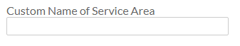
6 - The "Custom Name of Service Area" field within the user interface of Create a Service Area
The last option is the name of the resulting .KML file. The field “Name Your Output” can be used to enter the file name, with “Service Area” being the default name.
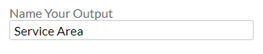
7 - The "Name Your Output" field within the user interface of Create a Service Area

Drawing a Shape
Just like with the geography list, the first option is the type of service area and should be set to “Single Service Area.”
Go past the default option of “Select Service Area” and click on the radio button next to “Draw Service Area” to use the drawing functionality.
Zoom in the map to the area that will be drawn as the service area and then click on “Polygon.”
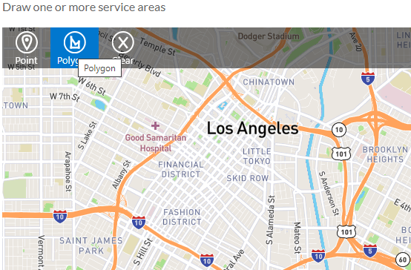
8 - The map within Create a Service Area
Simply click to start drawing. Each click will place a point on the map.
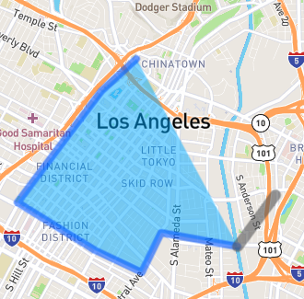
9 - Creating a shape
When the final point is placed, click on “Done.”
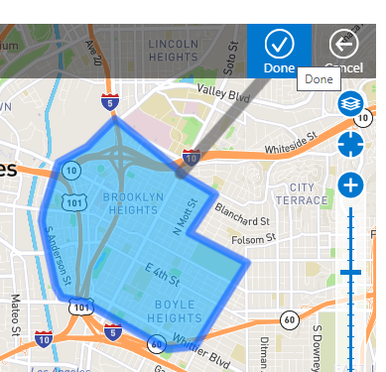
10 - Completing the shape
Once the shape is complete, the app will ask for a label which will update the name tags of the new shape. Whatever is entered into this will become the name of the shape and will appear in the output reports.
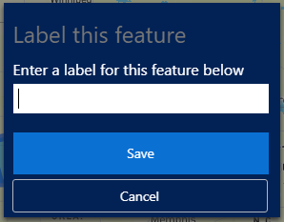
11 - Naming the shape once it's drawn
If a mistake is made, “Cancel” and/or “Clear” can be clicked on from any stage.
When complete, the “Name Your Output” can be updated to create the file name.

Part 3. How To Create Multiple Shapes for Branch Service Areas
Creating multiple shapes to be used as branch service areas within Gale Analytics can be created with the Create a Service Area app. As mentioned above, there are two main ways to create the branch service areas: by selecting from a geography list or from drawing the lines on a map.

Geography List
Within the Create a Service Area App, the first option is the type of service area. The options here are either “Single Service Area” or “Multiple Branch Areas.” Select “Multiple Branch Areas” and each of the selections will be output as a unique shape.
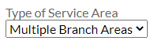
12 - The "Type of Service Area" field within Create a Service Area, this time showing the "multiple" option
The field “Custom Name of Service Area” will not work with the multiple shapes, but will instead name each branch shape with the same name.
The resulting file will be a single .KML file that contains multiple shapes within it.

Drawing Multiple Shapes
Using the drawing function to create multiple shapes works the same as when drawing single shapes. Once the map is drawn and named, click on “Polygon” again to draw the next shape. With the type of service area set to “Multiple Branch Areas” each shape drawn will be output in the .KML file as a distinct shape.
When naming the shapes, since each shape can be given a different name, there are some options to use to name the shapes, depending on which app the shapes will be used in and what names are needed for the output.
If the branch shapes are going to be used in the Branches app, and the patron data includes a location code, the branch shapes can be named with the same location code. In those instances, the branch location can be matched with the shape by location code.
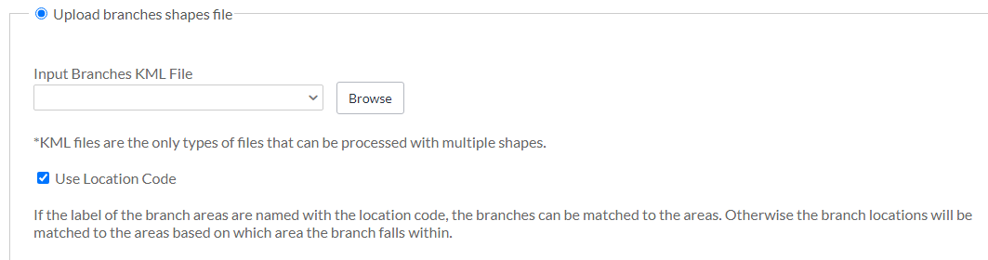
13 - The Branches app using the Location Code
If the branch shapes are going to be used in the Community Insights app, then the branch shapes can be given a more descriptive name, as this name will be used as the value of the Branch Name filter on the Tableau report.
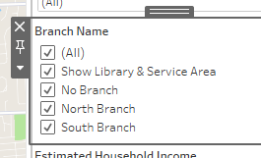
14 - The branch names as seen in the Tableau report from Community Insights
Branch points can also be added to the map within the drawing function. For more details, go to Part 5. Including Branch Points in this document.

Part 4. Editing Existing Shape Files
The Create a Service Area can edit existing shape files in certain circumstances. The app can update the name tag in a single-shape file and can convert a line to a polygon is both a single- and multi-shape files.
Branch points can also be added to an existing .KML file. For more details, go to Part 5. Including Branch Points in this document.
There are, however, a few things that the Create a Service Area app cannot do, including combining multiple shape files into a single .KML file or editing the name tags on multiple-shape files. Google Earth and Google Maps both provide some of this functionality, though there are limits.

Editing the Name Tag
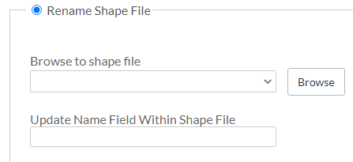
15 - The "Rename Shape File" section of Create a Service Area
The “Rename Shape File” section can be used to update the name tag of a single-shape file. If this section is used on a multiple-shape file then all shapes will be updated to the same name. To use, upload the spatial file and fill in the name to update to in “Update Name Field Within Shape File.”
There needs to be quotes around the value when updating the name.
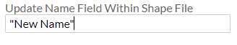

Convert Lines to Polygons
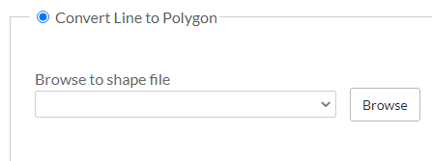
16 - The "Convert Line to Polygon" section of Create a Service App
If a single- or multiple-shape file contains a line instead of a polygon, the Gale Analytics app it was uploaded to will have an error (see above for details). In these instances, the Create a Service Area app has a section called “Convert Line to Polygon.” Any type of shape file can be uploaded and the output will be converted to a polygon and a .KML file. If it is a multiple-shape file any shapes that are lines will be converted, and any shape that is a polygon will simply be passed through.

Editing Name Tags in Multiple-Shape Files
One of the limitations in the Create a Service app is updating the names of multiple-shape files. However, Google Earth allows the upload of a multiple-shape file and has tools to update the names. Google Maps also allows the update of multiple-shape files and has tools to update the names. This document will go through the steps to do both, starting with Google Earth.
Branch points can also be added within both Google Earth and Google Maps. For more details, go to Part 5. Including Branch Points in this document.

Google Earth Steps
- Browse to https://earth.google.com/
- On the left-hand side of the screen is the menu. Click on “Projects” and then “Open” which will show the upload menu.
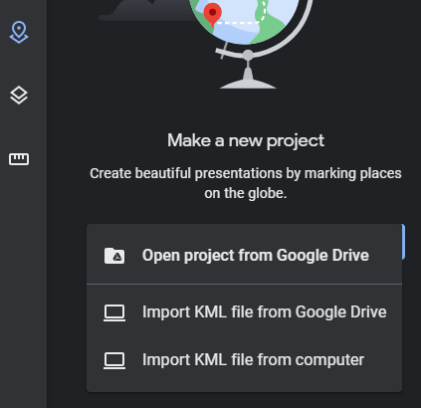
17 - The project menu from Google Earth
- Browse to a .KML file and import. The map within Google Earth will update and show the names and outlines of the shapes.
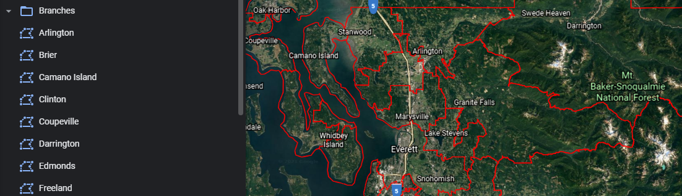
18 - A view of the different shapes within Google Earth
- Hovering over one of the shape names will bring up the editing menu. Click on the pencil to go to the editing view of that shape. From there, the name can be updated, though it appears as “Title.”
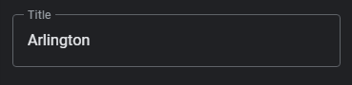
19 - The name within the shape
- Clicking on the back arrow at the top of the Google Earth page (not the back button in the browser) will go back to the list of shapes. These steps can be repeated until all shapes have had their names updated as desired.
- Near the back arrow is an icon of three vertical dots. Click on the three dots to bring up the save menu.

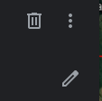
20 - Google Earth tools
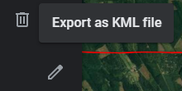
21 - Exporting menu

Once the file is exported as a .KML file it can be used within Gale Analytics

Google Maps Steps
Google Maps does require a Google email account to use the map editing features. Make sure to create an account and/or sign in before following these steps.
- Browse to https://www.google.com/maps/
- Click on the three lines which will bring up the menu, then click on “Your Places” from the menu.

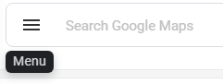
22 - Google Maps menu
- 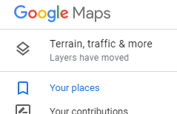
- 23 - Your Places

- When “Your Places” is clicked, Google will bring up the personal map tools. Click on “Maps” at the top. Then click on “Create Map” at the bottom of that menu.
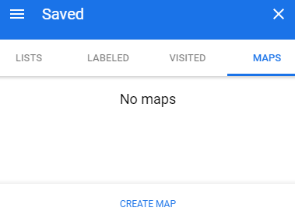
24 - Personal map tools within Google Maps
- Clicking on “Create Map” will open a new tab in the browser with a menu with the import tools ready. Click on “Import” from that menu to import the shape file.
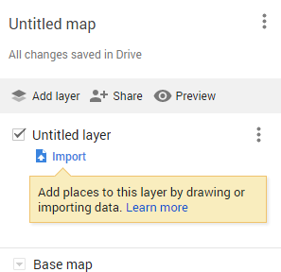
25 - Import tools
- Like Google Earth, Google Maps will display the shapes by name as well as outline them.
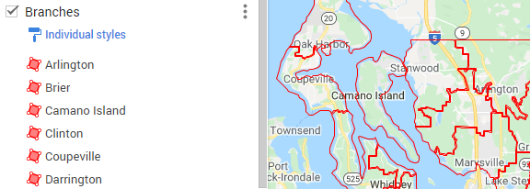
26 - A view of the different shapes within Google Maps
- Click on any of the shapes to bring up the details. From those details, click on the pencil icon to edit.
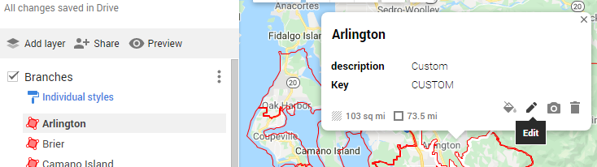
27 - The editing menu
- Edit the topmost field, that isn’t labelled. This will update the name of the shape. Then click save.
- Repeat for all the shape names that need to be edited.
- Once all editing is complete, click on the three dots to bring up a menu and click on “Export to KML/KMZ.”
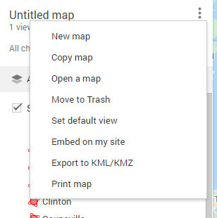
28 - Exporting to .KML
- On the save menu, check the box that says “Export as KML instead of KMZ.” In the Box, the default to download is “Entire map.” Select the name of the shape file first imported (though both “Entire map” and the original file name will work the same within Gale Analytics).
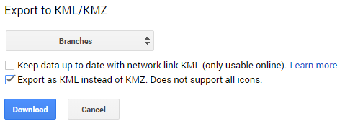
29 - Export menu
Once the file is exported as a .KML file it can be used within Gale Analytics

Combining Shape Files in Google Maps
If several single-shape files need to be combined into one .KML file for use in Gale Analytics, Google Maps offers the ability to combine them.
As above, Google Maps does require a Google email account to use the map editing features. Make sure to create an account and/or sign in before following these steps.
The first steps are the same as editing the shapes in Google Maps.
- Browse to https://www.google.com/maps/
- Click on the three lines which will bring up the menu, then click on “Your Places” from the menu.

30 - Google Maps menu
- 31 - Your Places

- When “Your Places” is clicked, Google will bring up the personal map tools. Click on “Maps” at the top. Then click on “Create Map” at the bottom of that menu.
32 - Personal map tools within Google Maps
- Clicking on “Create Map” will open a new tab in the browser with a menu with the import tools ready. Click on “Import” from that menu to import the shape file.
33 - Import tools
- Click on “Add layer” and then import to bring in the next shape.
- Repeat until all the shapes are uploaded or until the limit of 10 layers has been reached. (The limit of 10 is the number of layers that can be imported, with each shape file creating a new layer. This limit has a workaround that will be detailed below.)
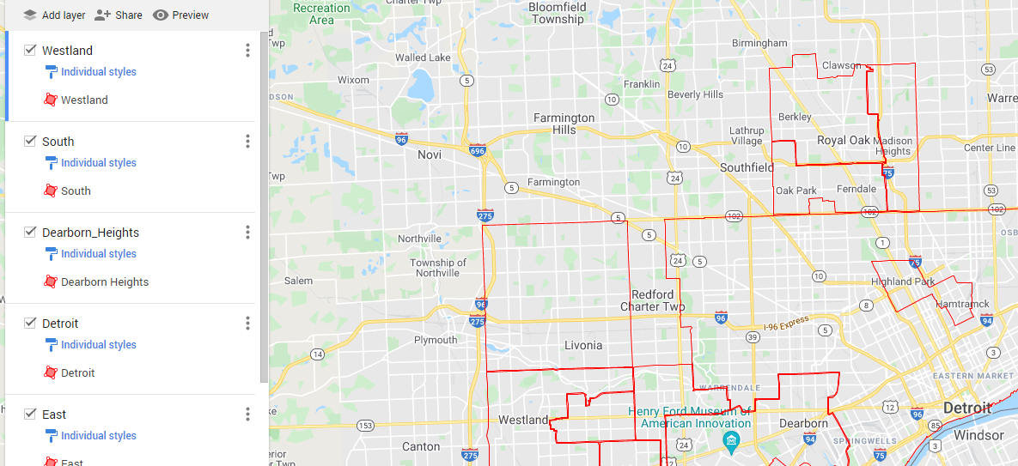
34 - Individual shapes uploaded into Google Maps
- Click on the three dots to bring up a menu and click on “Export to KML/KMZ.”
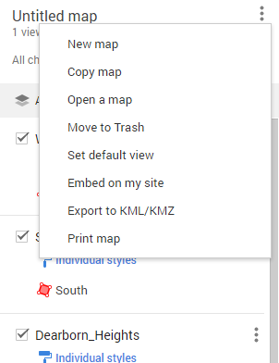
35 - Exporting to .KML
- On the save menu, check the box that says “Export as KML instead of KMZ.”
- The multiple-shape file can now be used in Gale Analytics

Workaround for 10 Layer Limit.
Using a combination of Google Maps and the Create a Service Area app, the limit of 10 shapes can be overcome.
The actual limit, is 10 layers in a map and each uploaded shape is uploaded into a new layer. However, an individual layer can hold as many as 2,000 shapes. So to get around the limit, use the Create a Service Area app to combine the separate layers into one layer.
- Follow the steps for combining shapes in Google Maps until the limit of 10 is reached.
- Output the .KML file.
- Go to Gale Analytics and the Create a Service Area app.
- Run the app, using the “Rename Shape File” section of the app
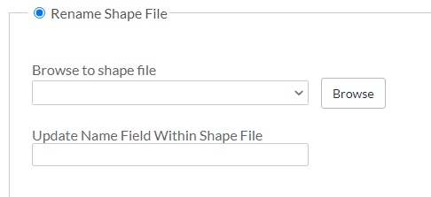
36 - The "Rename Shape File" section within Create a Service app in Gale Analytics
- If the “Update Name Field Within Shape File” is left blank, then the name tags will not be updated. Gale Analytics always take the shapes that are on multiple layers and reduce them down to one for faster processing, so by running the shape file through the app, all the shapes are reduced to one layer.
- Save the resulting file.
- Go back to Google Maps and create a new map, uploading the newly created file.
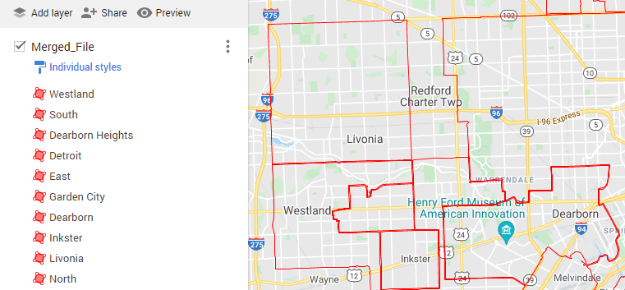
37 - The shapes collected into one layer
- The file takes up only one layer and nine more layers can be added.
- Repeat all steps as necessary until all shapes are combined into one file.

Part 5. Including Branch Points
Individual branch locations can also be included as part of the branches .KML file. The branch points can either be created at the same time as the branch points or added to an existing .KML shapes file.

Points in the Create a Service Area App
There are two ways to include branch points in the Create a Service Area app: when drawing branch shapes, or by adding an input file of branch addresses to an existing .KML File.

Drawing Points
Click on “Point.”
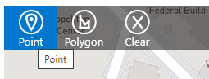
40 - Choosing the "Point" option
This will create a point that you can place on the map.
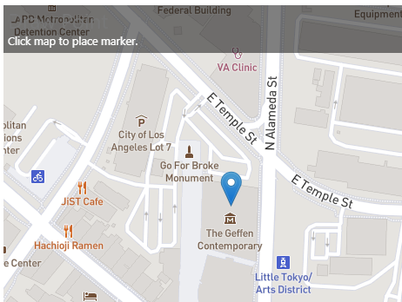
41 - Create the point on the map
Just like when making a shape, once you click to place the point you will get an option to name it. The name that is entered here is what will appear on the output reports.
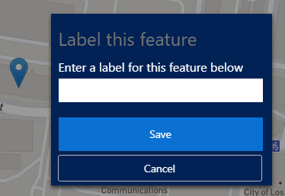
42 - Label the point once it's created

Adding to an Existing .KML File
When using this option within the Create a Service Area app, the branches must be a list of branch names and addresses in a text or Excel file.
Upload an existing shape file, then upload a branches list and map the fields.
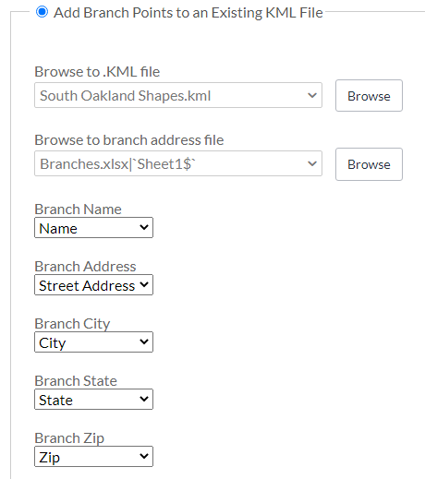
43 - Browsing to the files and mapping the fields

Google Earth and Google Maps
Points can be added at any time in both Google Earth and Google Maps, either when creating the shapes for the first time or adding to an existing .KML file.
In Google Earth, use the point button to add a point to the map.
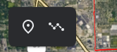
44 - Google Earth point option
Once added, you will be presented with an option to name the point.
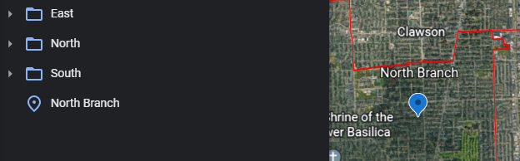
45 - Adding the point in Google Earth
In Google Maps, use the “Add Marker” button.
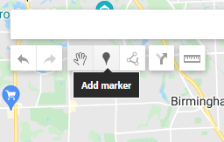
46 - Google Maps point option
Once added, you will be presented with an option to name the point.
In both of the Google options, it doesn’t matter where the point is included relation to the shapes. The points can be their own layers, grouped, or scattered throughout the existing layers. They will be ingested the same way in Gale Analytics.

Thank you for using Gale Analytics!

